DIS-EUR-Vinca Culture

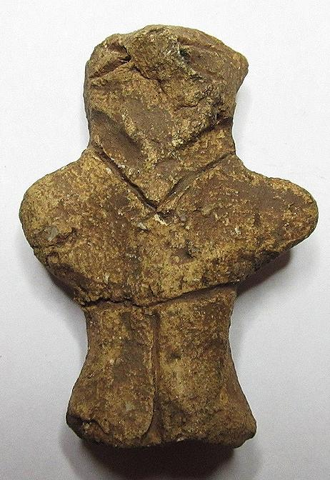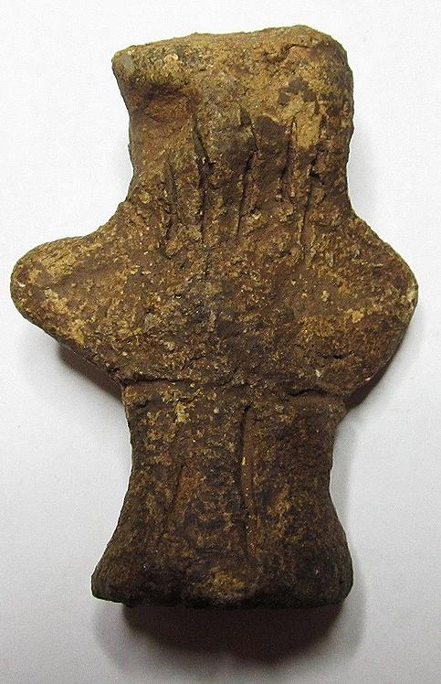 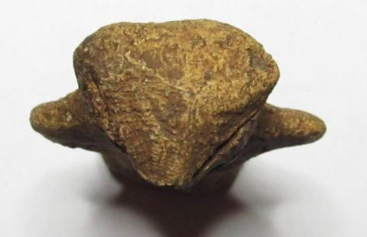

Formal Label: Neolithic Vinca fired ceramic anthropomorphic figurine, cal. 4500 BCE. This male figurine has incised trousers on the front and rear. It also has an incised neck opening of a shirt on the front and long hair on the rear. Its arms are stretched outward.Its eyes are wide open.

Accession Number:

Date or Time Horizon: cal. 4500 BCE.

Geographical Area: Central Europe

Cultural Affiliation: Vinca

Media: Fired Terracotta

Dimensions:

Weight:

Provenance:

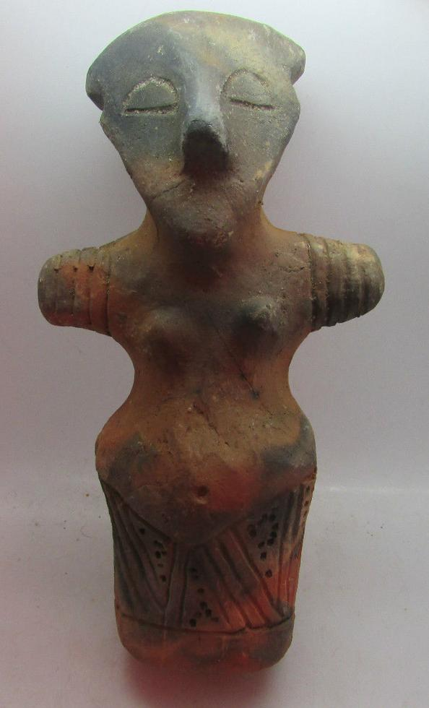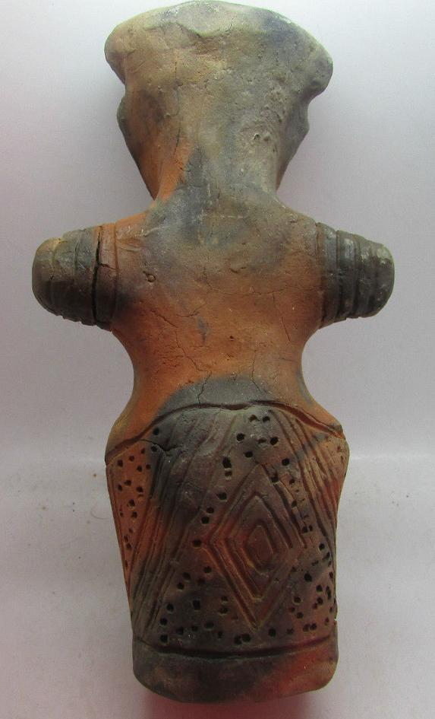

Formal Label: Neolithic Vinca fired cylindrical ceramic anthropomorphic female figurine, cal. 4500 BCE. This female figurine has an incised skirt with three interlocking triangular incisions on the front and a triple diamond sign within a quadruple triangular incision on the rear. This figurine wears a cap and four bracelets on each arm. Its arms are stretched outward. Its eyes are closed.

Accession Number:

Date or Time Horizon: cal. 4500 BCE

Geographical Area: central Europe

Cultural Affiliation: Vinca

Media: Fired Clay.

Dimensions: length: 13.5 cm

Weight:

Provenance: Ex: Michael Davies 2 hanover court Didcot Oxfordshire ox11 8nu United Kingdom

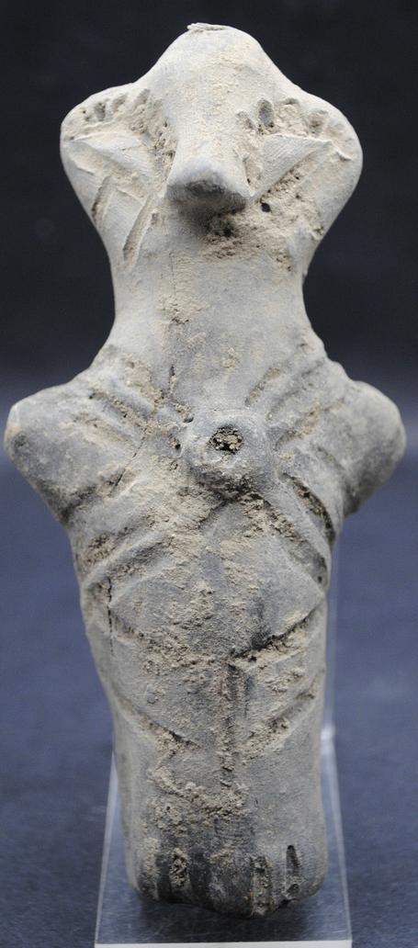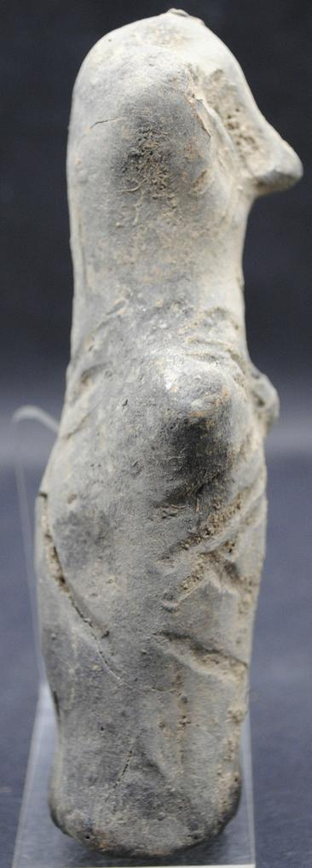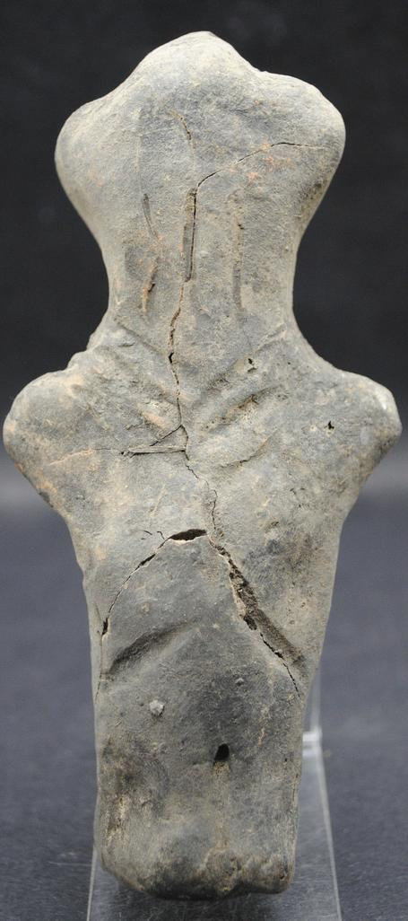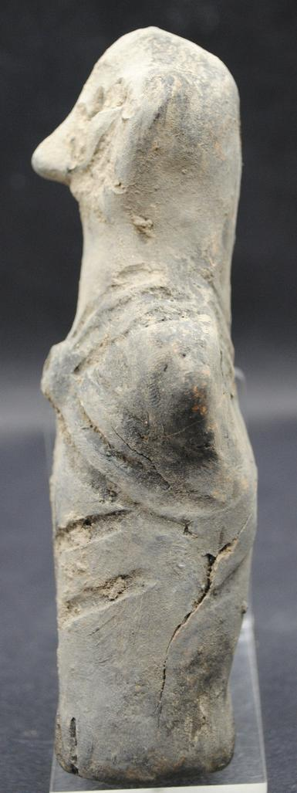

Formal Label: Neolithic Vinca fired ceramic male anthropomorphic figurine, cal. 4500 BCE. It has no discernible breasts. It wears a circular gorget that is fastened two ways -- over and under the shoulders It wears flounced trousers with a vertical incision separating the legs. It also has long hair. Some cracks but no repairs.

Accession Number:

Date or Time Horizon: cal. 4500 BCE

Geographical Area: Central Europe

Cultural Affiliation: Vinca

Media: Fired Clay

Dimensions: 135 x 62mm.

Weight:

Provenance: Ex: Ancient-Artefacts-UK 11 Wessex Road, Didcot, Oxfordshire, ox11 8bu, United Kingdom.

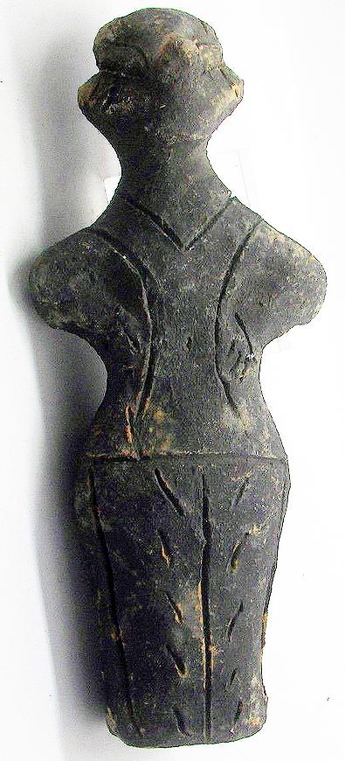 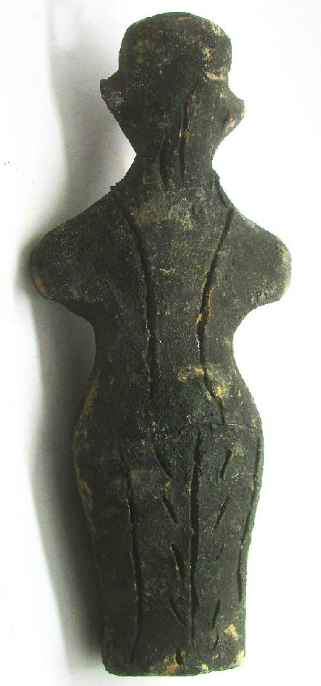

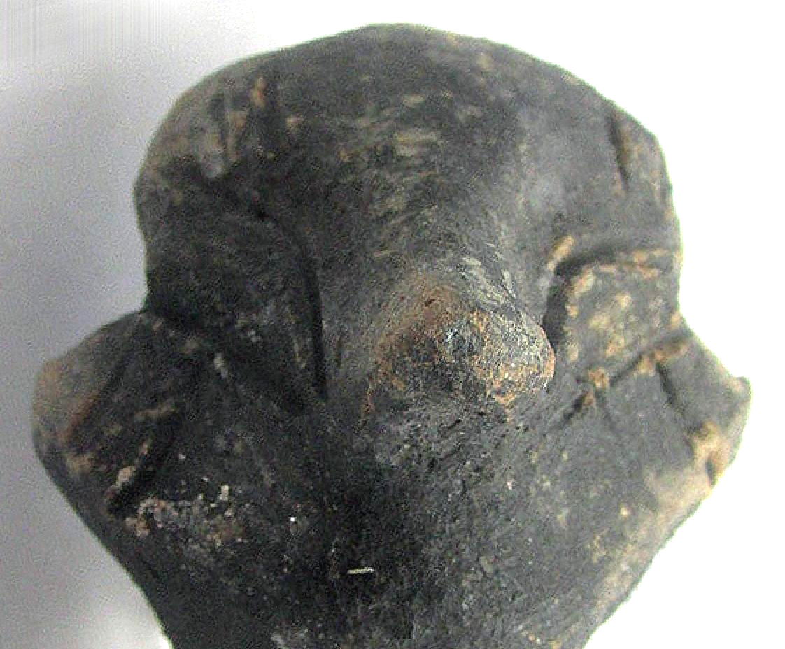

Formal Label: Neolithic Vinca fired ceramic anthropomorphic figurine, cal. 4500 BCE.

Accession Number:

Date or Time Horizon: cal. 4500 BCE

Geographical Area: Central Europe

Cultural Affiliation: Vinca

Media: Fired clay.

Dimensions: length: 15.1 cm.

Weight:

Provenance: Michael Davies, 2 Hanover Court, Didcot, Oxfordshire, ox11 8nu, United Kingdom

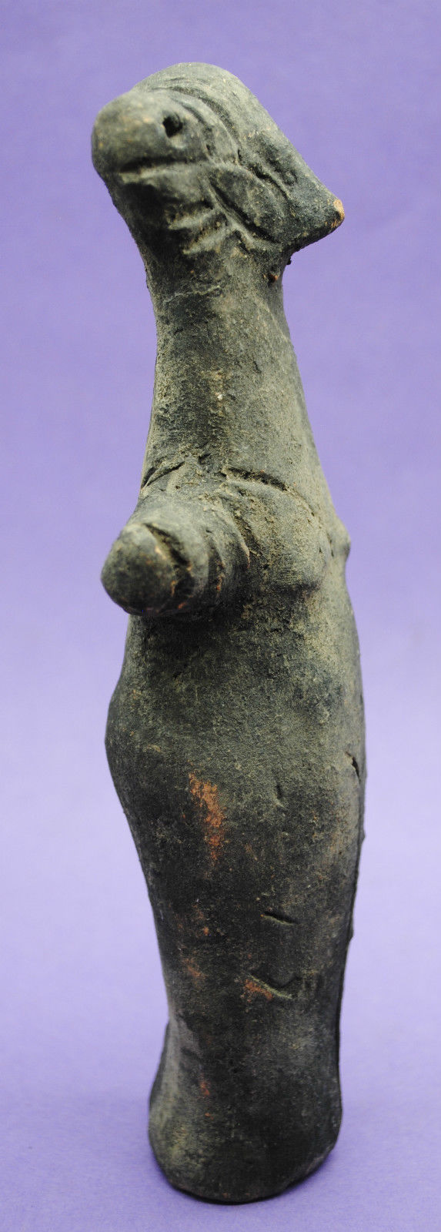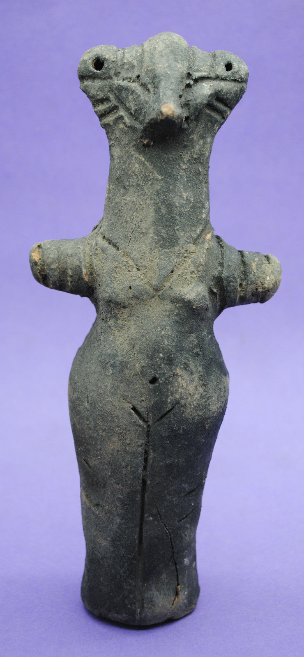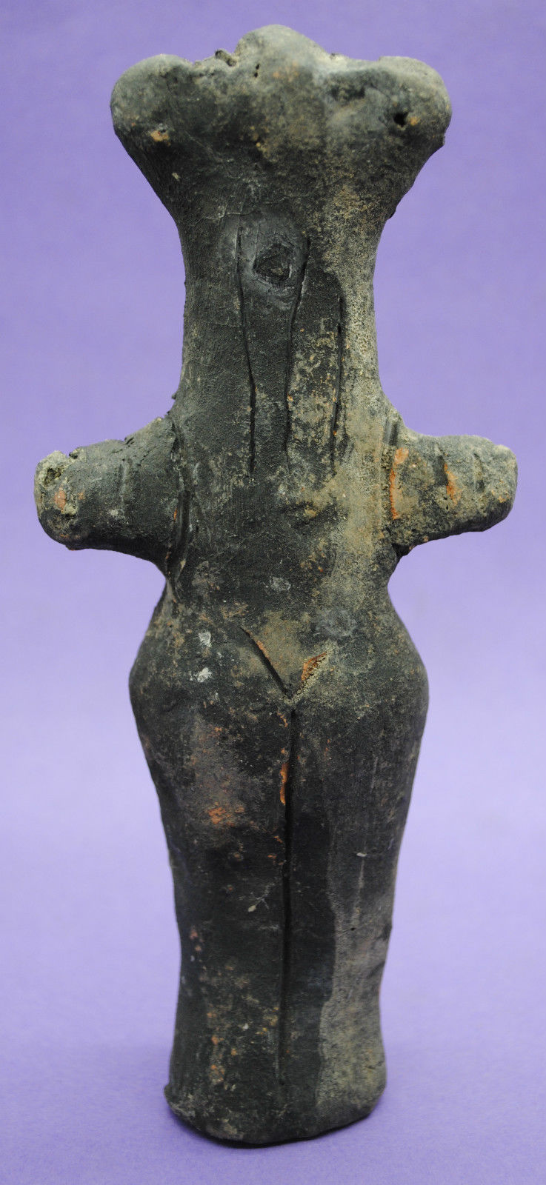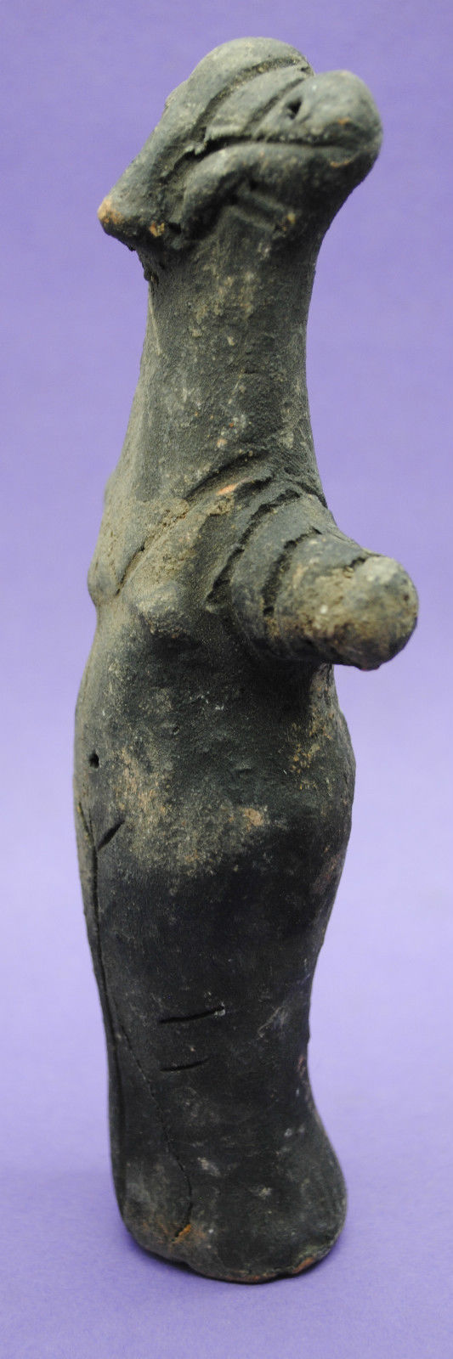

Formal Label: Neolithic Vinca fired ceramic anthropomorphic figurine, cal. 4500 BCE.

Accession Number:

Date or Time Horizon: cal. 4500 BCE.

Geographical Area: Central Europe

Cultural Affiliation: Vinca

Media: Fired Clay

Dimensions: 170 x 74mm

Weight:

Provenance: Anglo-Antiquities, 33 Medlock Grove, Didcot, Oxfordshire, ox11 7xy, United Kingdom

